1. **Register**

INSERT into UserPlus( UserID, Password, FirstName, LastName, Address, City, State, ZipCode, Phone, Email, AccountNum, AccountCreationDate, CreditCardNum, Preferences) VALUES ( ?, ? ,?, ?, ?, ?, ?, ?, ?, ?, ?, ?, ?, ?);

**Statements:**

INSERT INTO UserPlus VALUES(1, 'apples', 'Michael', 'Thorne', '4363 Arrowood Drive', 'Jacksonville', 'FL', 32216, '9044166609', 'MichaelCThorne@gmail.com', 1, NOW(), '5443350608517143', 'applePicking');

INSERT INTO PagePlus(PageID, PostCount) VALUES(?, ?);

INSERT INTO PersonalPage(PageId, OwnerID) VALUES(?, ?);

INSERT INTO HasAPersonal(UserID, PersonalPageID) VALUES(?, ?);

**Output:**

SELECT * FROM UserPlus WHERE UserId = 1;

SELECT * FROM PersonalPage WHERE OwnerId = 1;

SELECT * FROM PagePlus WHERE PageId = 1;

SELECT * FROM HasAPersonal WHERE UserID = 1;

UserId Password FirstName LastName Address City State ZipCode Phone Email AccountNum AccountCreationDate CreditCardNum Preferences

1 apples Michael Thorne "4363 Arrowood Drive" Jacksonville FL 32216 9044166609 MichaelCThorne@gmail.com 1 "2016-11-07 17:02:58" 5443350608517143 applePicking

  

1. **Sign in and sign out**

SELECT * FROM UserPlus WHERE userId=? AND password=?;

**Statements:**

SELECT * FROM UserPlus WHERE userId=1 AND password="apples";

**Output:**

UserId Password FirstName LastName Address City State ZipCode Phone Email AccountNum AccountCreationDate CreditCardNum Preferences

1 apples Michael Thorne "4363 Arrowood Drive" Jacksonville FL 32216 9044166609 MichaelCThorne@gmail.com 1 "2016-11-07 17:02:58" 5443350608517143 applePicking

1. **Post messages into personal page**

INSERT INTO POST(PostID, DateCreated, Content, CommentCount, AuthorID) values (?, ?, ?, ?, ?);

INSERT INTO PostedTo(PostID, PageID) values (?, ?);

**Statements:**

INSERT INTO Post (PostId, DateCreated, Content, CommentCount, AuthorId) VALUES (1, NOW(), 'envisioneer frictionless deliverables', 10, 1);

INSERT INTO PostedTo(PostID, PageID) VALUES (1, 1);

**Output:**

SELECT * FROM Post WHERE AuthorId = 1;

SELECT * FROM PostedTo WHERE PostID = 1;

 

1. **Send a message**

SELECT UserId From UserPlus WHERE UserId=?;

INSERT INTO Message(MessageID, DateSent, ReceiverID, SenderID, Subject, Content) values (?, ?, ?, ?, ?, ?);

INSERT INTO Send(Sender, MessageID) values (?, ?);

**Statements:**

INSERT INTO Message(MessageID, DateSent, ReceiverID, SenderID, Subject, Content) values (1, NOW(), 2, 1, “subject”, “apples”);

INSERT INTO Send(Sender, MessageID) values (1, 1);

SELECT * FROM Message WHERE SenderId = 1;

SELECT * FROM Send WHERE Sender = 1;

**Output:**

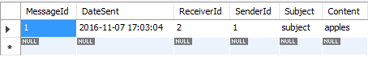 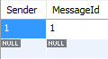

1. **Receive a message**

SELECT UserId From UserPlus WHERE UserId=?;

INSERT INTO Receive(Receiver, MessageId) values (?, ?);

**Statements:**

SELECT UserId FROM UserPlus WHERE UserId=2;

INSERT INTO Receive(Receiver, MessageId) VALUES (2, 1);

**Output:**

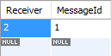

1. **Delete a message**

DELETE FROM Message WHERE MessageID = ?;

**Statements:**

DELETE FROM Message WHERE MessageID = 1;

**Output:**



1. **Create Group**

INSERT INTO GroupPlus(GroupID, GroupName, Owner, Type) values (?, ?, ?, ?);

INSERT INTO PagePlus(PageID, PostCount) values(?, ?);

INSERT INTO GroupPage(PageId, GroupID) values(?, ?);

INSERT INTO HasAGroupPage(GroupID, GroupPageID) values(?, ?);

INSERT INTO HasAccessToGroup(UserId, PageID, GroupID) values (?, ?, ?);

**Statements:**

INSERT INTO GroupPlus (GroupId, Owner, GroupName) VALUES (26, 1, 'Automated value-added process improvement');

INSERT INTO PagePlus (PageId, PostCount) VALUES (26, 0);

INSERT INTO GroupPage(PageId, GroupID) VALUES(26, 26);

INSERT INTO HasAGroupPage(GroupID, GroupPageID) VALUES(26, 26);

INSERT INTO HasAccessToGroup(UserId, AdderId, PageID, GroupID) VALUES(1, NULL, 26, 26);

**Output:**



1. **Search for a user and add him to a group**

SELECT * FROM HasAccessToGroup WHERE AdderID = ? AND GroupID = ?;

INSERT INTO HasAccessToGroup(UserID, PageID, GroupID) values (?/*Target_Id*/, ?, ?);

**Statements:**

SELECT * FROM HasAccessToGroup WHERE AdderID = NULL AND GroupID = 26 AND UserID = 1;

INSERT INTO HasAccessToGroup(UserID, AdderID, PageID, GroupID) VALUES (11, 1, 26, 26);

**Output:**



1. **Make a post**

SELECT * FROM HasAPersonal WHERE UserID = ? AND PersonalPageID = ?; -- check if it is a personal page

SELECT * FROM HasAccessToGroup WHERE AdderID = ? AND GroupId = ?; -- check if has access to group

INSERT INTO PostedTo(PostID, PageID) values (?, ?); -- insertion

**Statements:**

SELECT * FROM HasAPersonal WHERE UserID = 1 AND PersonalPageID = 1;

INSERT INTO Post (PostId, DateCreated, Content, CommentCount, AuthorId) VALUES (1, NOW(), 'envisioneer frictionless deliverables', 10, 1);

INSERT INTO PostedTo(PostID, PageID) VALUES(1, 1);

**Output:**



1. **Comment on a post**

INSERT INTO Comment(CommentID, DateCreated, Content, AuthorID) VALUES (?, ?, ?, ?);

INSERT INTO CommentOn(CommentID, PostID) VALUES (?, ?);

**Statements:**

INSERT INTO Comment(CommentID, DateCreated, Content, AuthorID) VALUES (1, NOW(), '2', 1);

INSERT INTO CommentOn(CommentID, PostID) VALUES(1, 1);

**Output:**



1. **Like a post**

INSERT INTO LikesPost(PostID, UserID) VALUES(?, ?);

**Statements:**

INSERT INTO LikesPost(PostID, UserID) VALUES (1, 1);

**Output:**

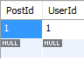

1. **Like a comment**

INSERT INTO LikesComment(CommentID, UserID) VALUES(?, ?);

**Statements:**

INSERT INTO LikesComment(CommentID, UserID) VALUES(1, 1);

**Output:**

SELECT * FROM LikesComment WHERE CommentID=1 AND UserID=1;

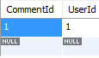

1. **Remove a user from a group**

DELETE FROM HasAccessToGroup WHERE UserID = ? AND GroupID = ?;

**Statements:**

DELETE FROM HasAccessToGroup WHERE UserID = ? AND GroupID = ?;

**Output:**



1. **Remove a post**

DELETE FROM PostedTo WHERE PostID = ? AND PageID = ?;

**Statements:**

DELETE FROM PostedTo WHERE PostID = ? AND PageID = ?; -- CASCADE will DELETE the post

**Output:**



1. **Remove a comment**

DELETE FROM CommentOn WHERE CommentID = ? AND PostID = ?;

**Statements:**

DELETE FROM CommentOn WHERE CommentID = 1 AND PostID = 1;

**Output:**



1. **Unlike a post**

DELETE FROM LikesPost WHERE PostID = ? AND UserID = ?;

**Statements:**

DELETE FROM LikesPost WHERE PostID = 1 AND UserID = 1;

**Output:**



1. **Unlike a comment**

DELETE FROM LikesComment WHERE CommentId = ? AND UserId = ?;

**Statements:**

DELETE FROM LikesComment WHERE CommentID = ? AND UserID = ?;

**Output:**



1. **Modify a post**

UPDATE Post SET DateCreated = ?, Content = ?, CommentCount = ? WHERE PostId = ?;

**Statements:**

UPDATE Post SET DateCreated = NOW(), Content = "hey whats up?", CommentCount = 1 WHERE PostId = 2;

**Output:**





1. **Modify a comment**

UPDATE Comment SET DateCreated = NOW(), Content = "this is great" WHERE CommentId = 5;

**Statements:**

UPDATE Comment SET DateCreated = NOW(), Content = "this is great" WHERE CommentId = 5;

**Output:**

*Before:*

**

*After:*



1. **Delete a group**

DELETE FROM GroupPlus WHERE GroupId = ?;

**Statements:**

DELETE FROM GroupPlus WHERE GroupId = 31;

**Output:**



AddEmployee.png

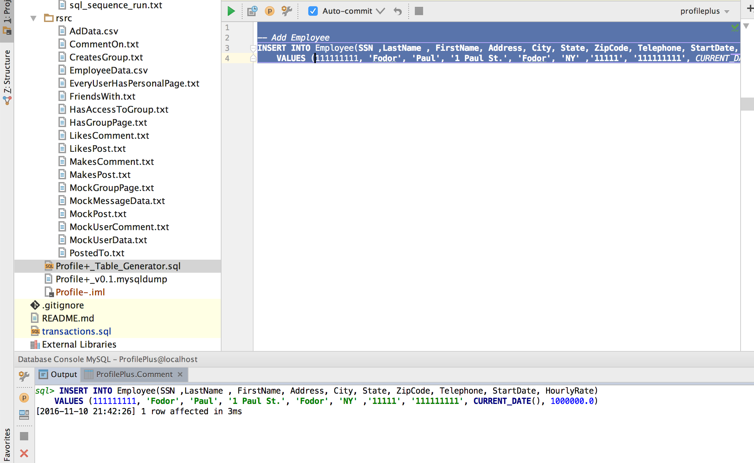

CommentToPost.png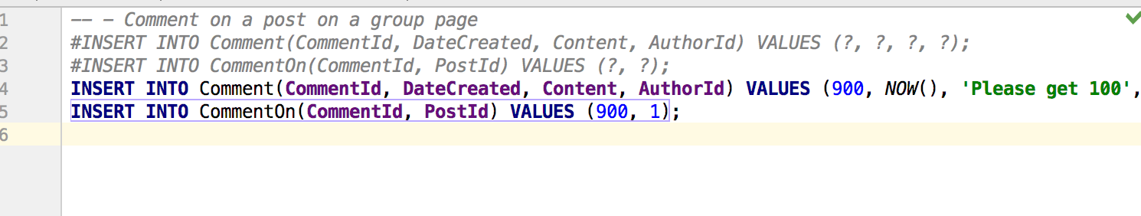

CommentToPost2.png



DeleteEmployee.png

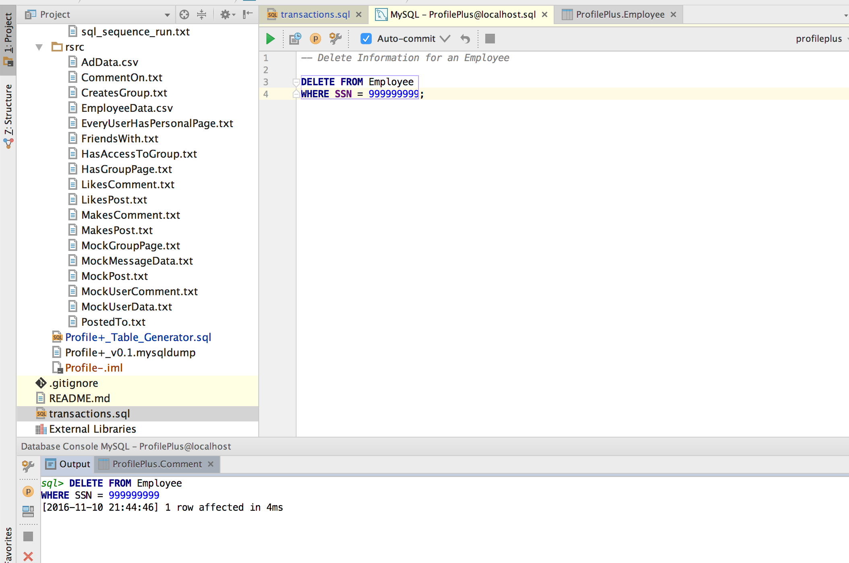

JoinGroup.png

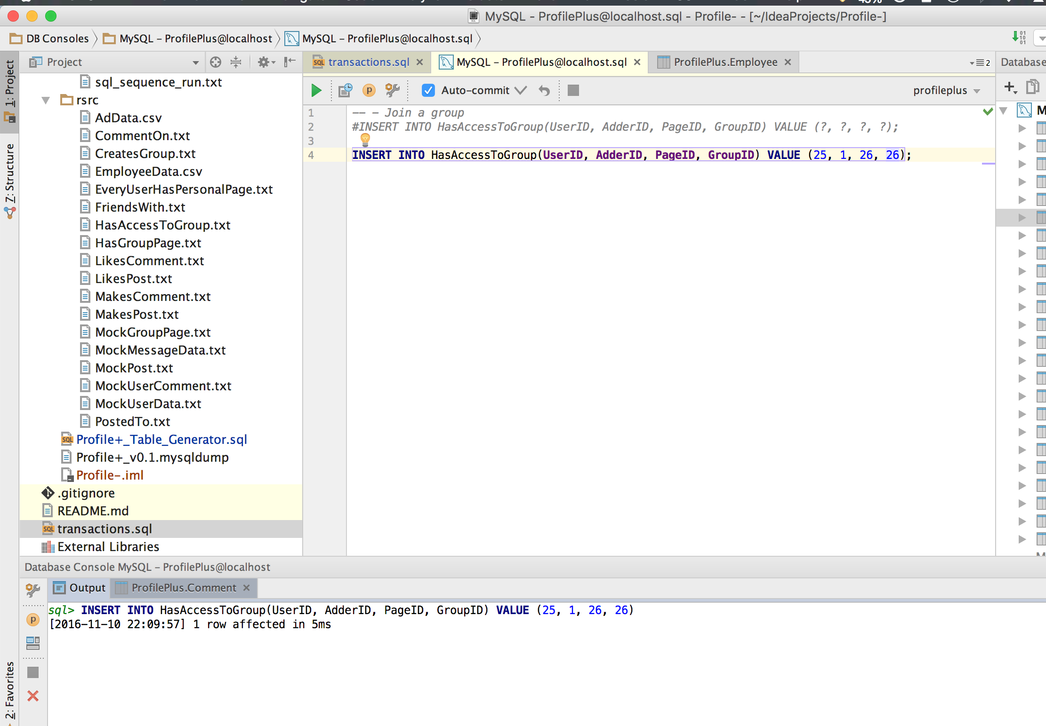

LikeaPostFromGroup.png

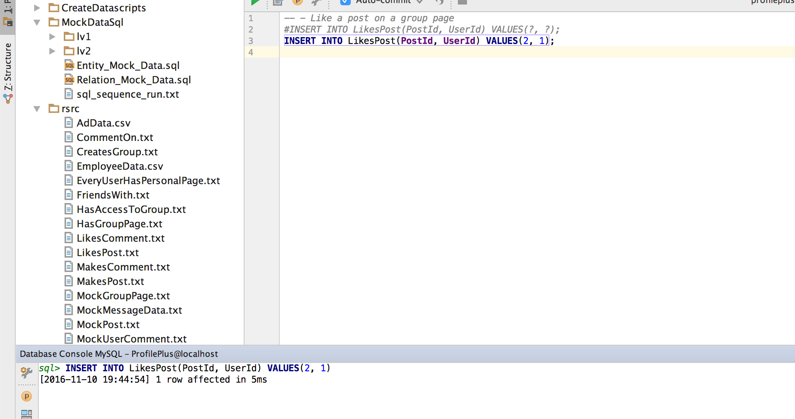

LikeCommentFromGroup.png

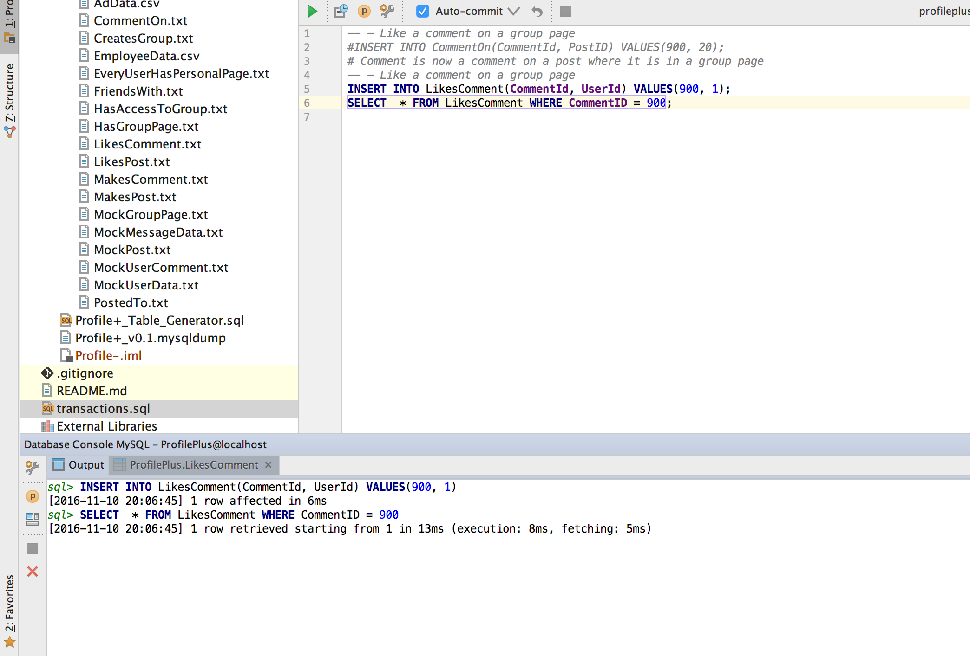

RemoveCommentFromGroup.png

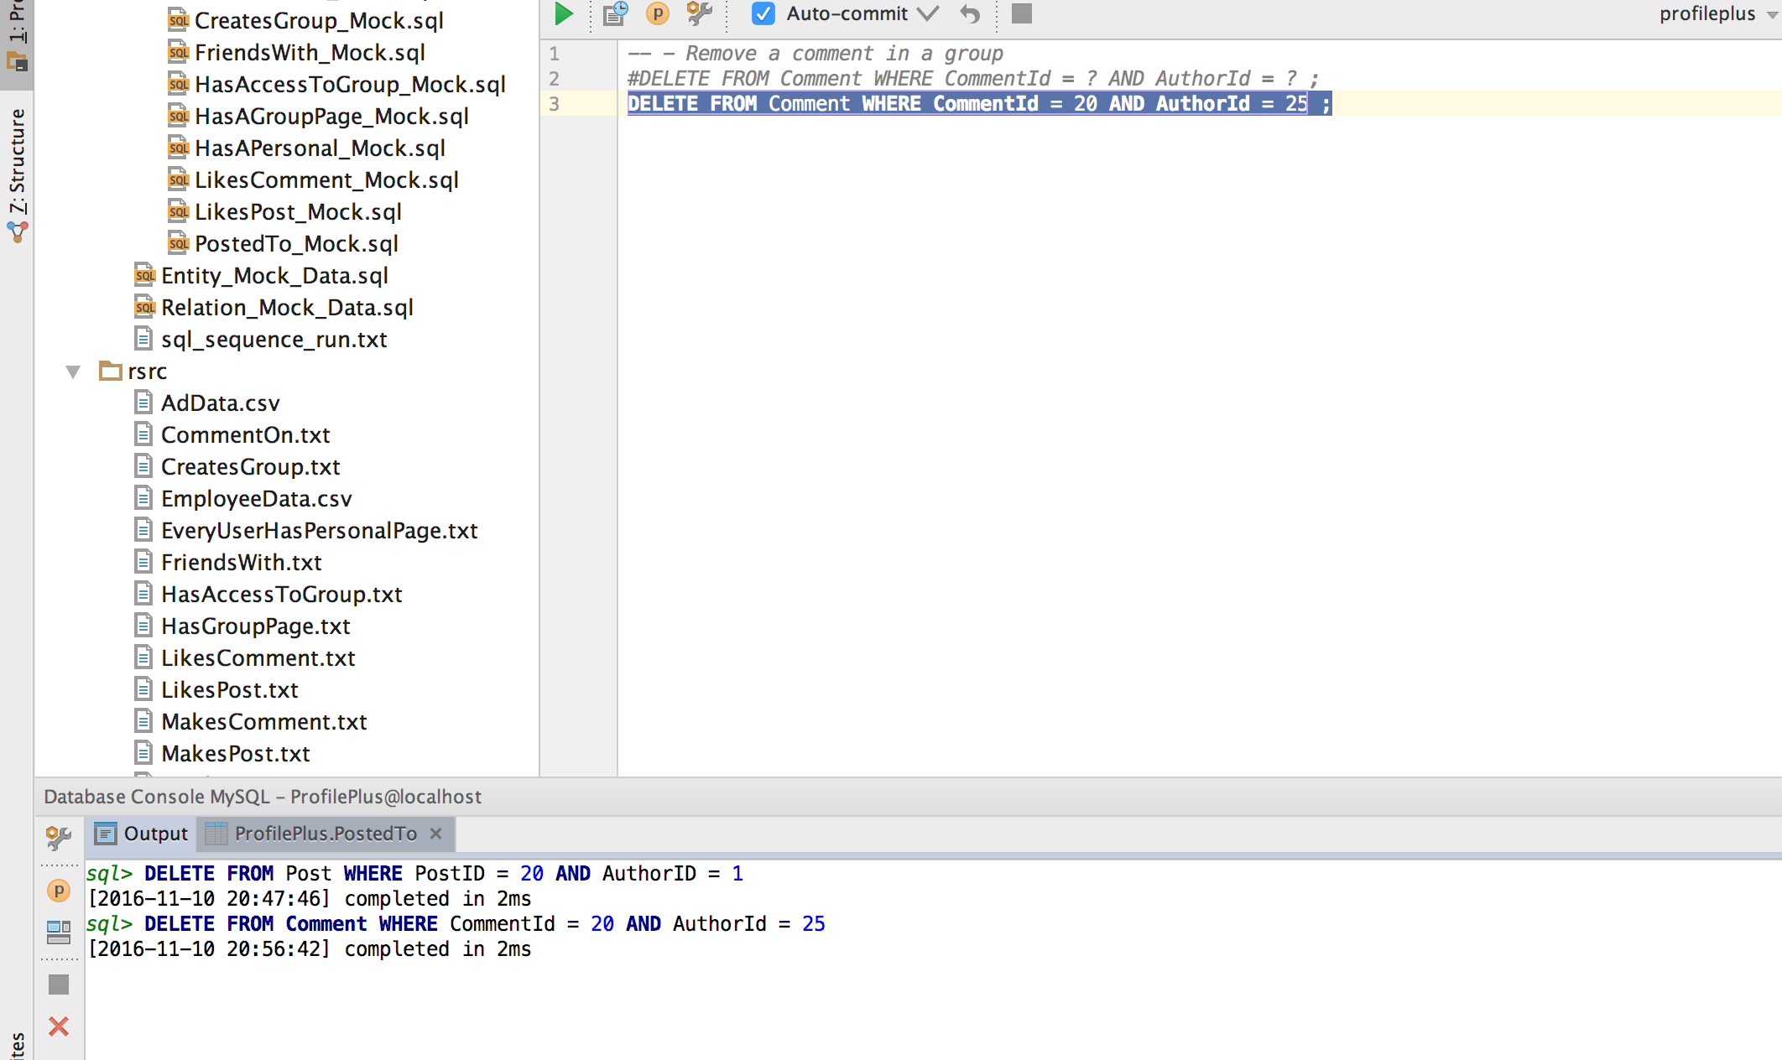

RemovePostFromGroup.png

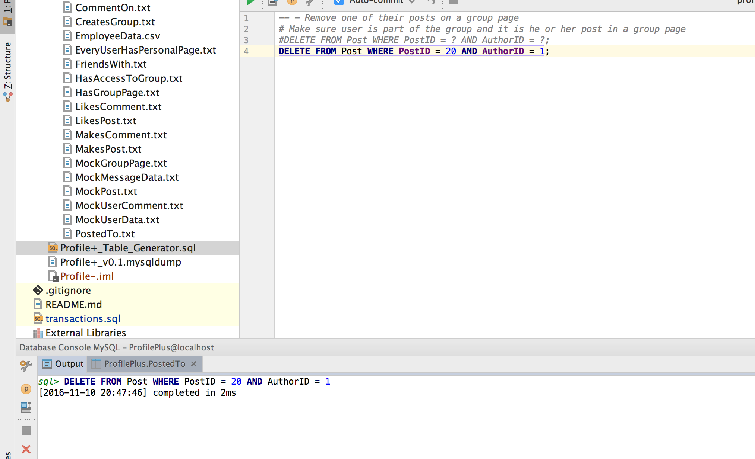

RenameGroup.png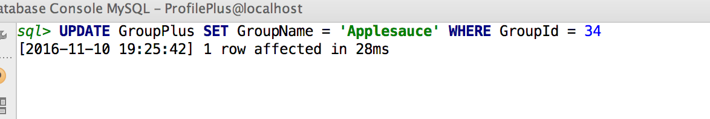

SelectHasAccess.png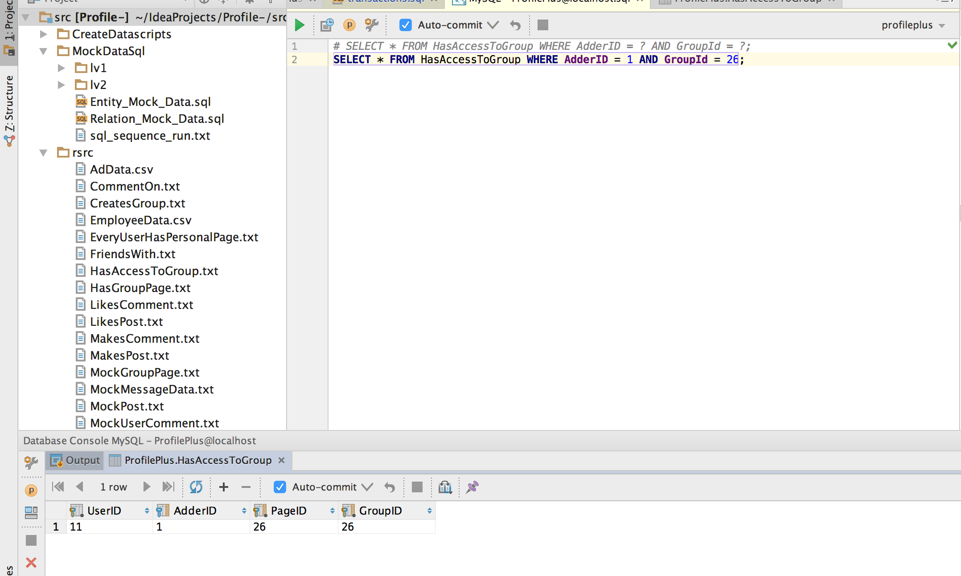

SelectHasAccessToGroup.png

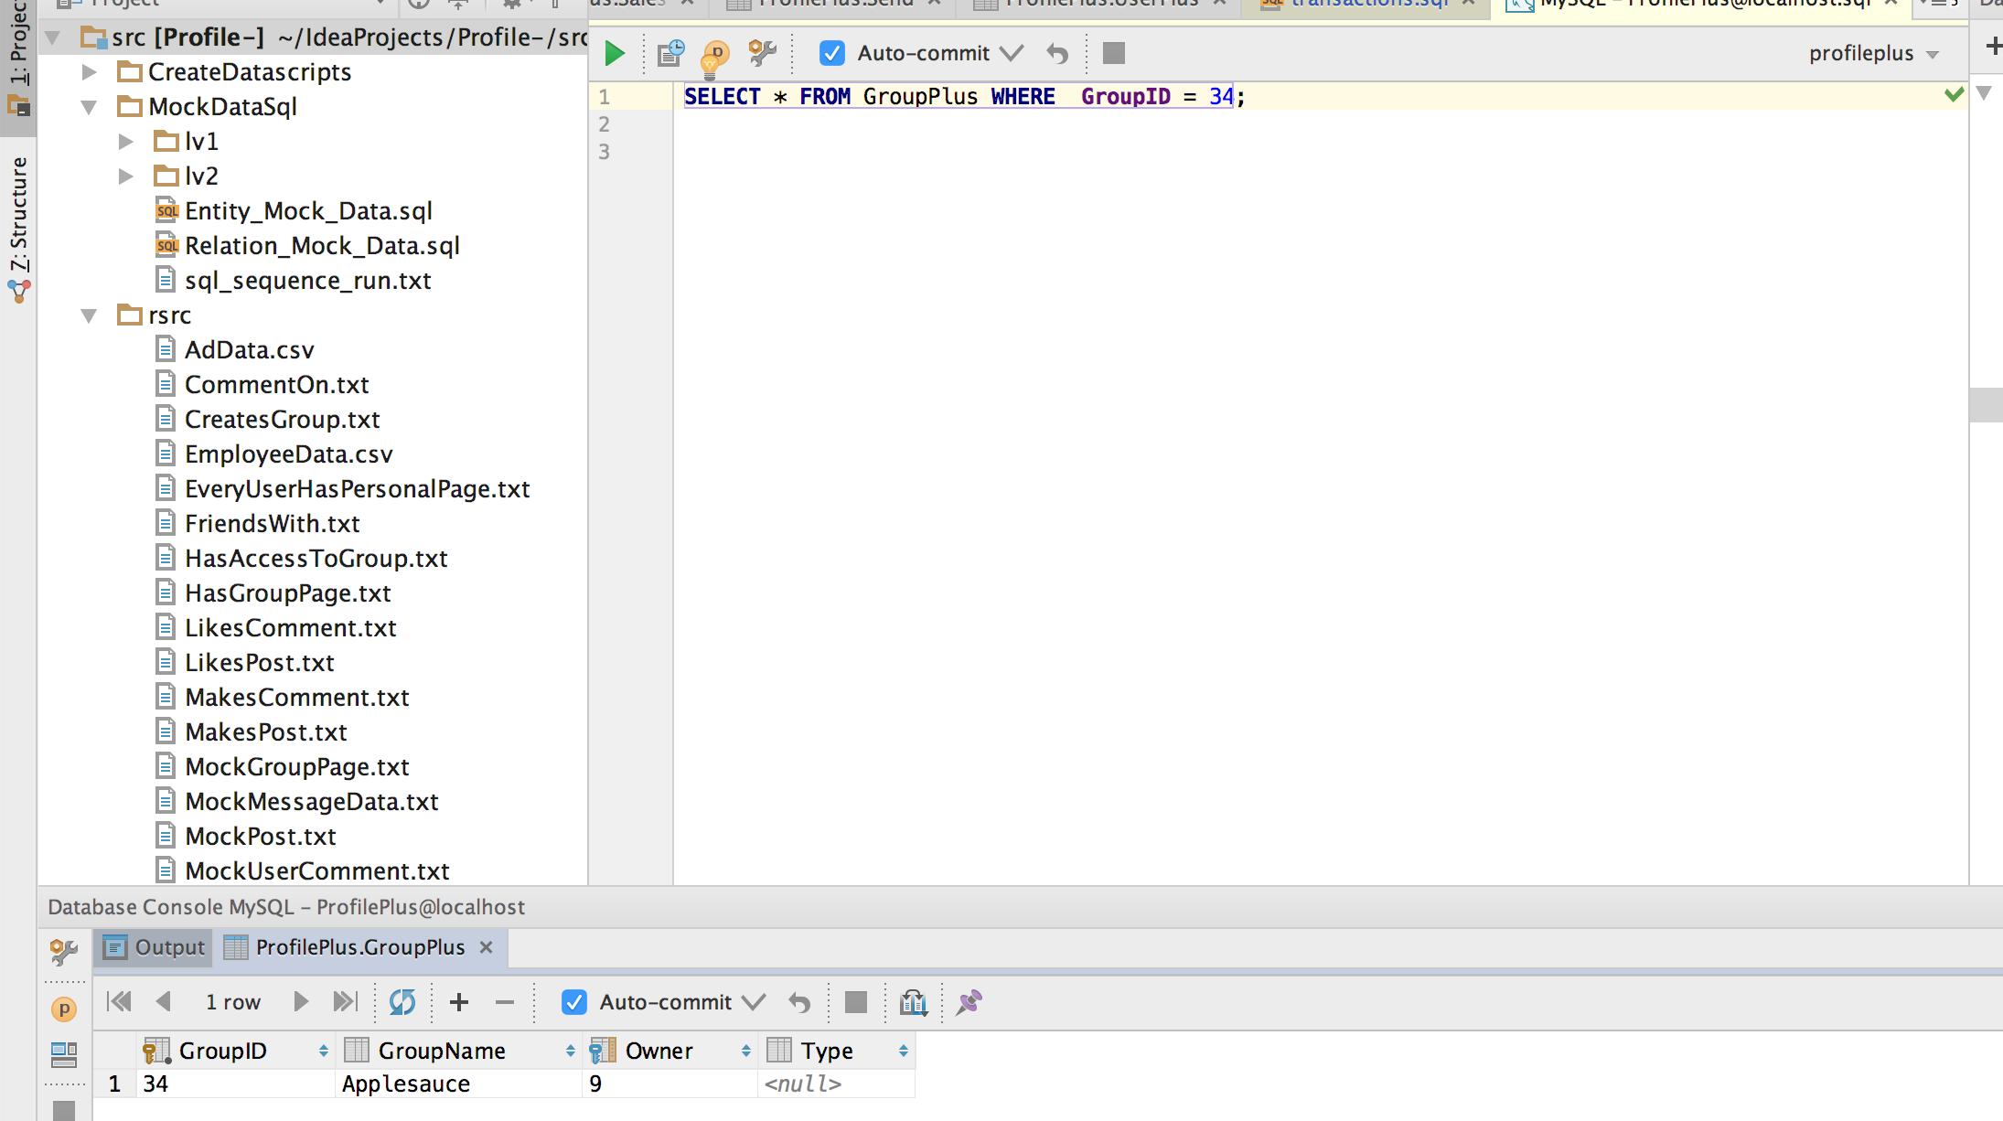

SelectHasPersonalPage.png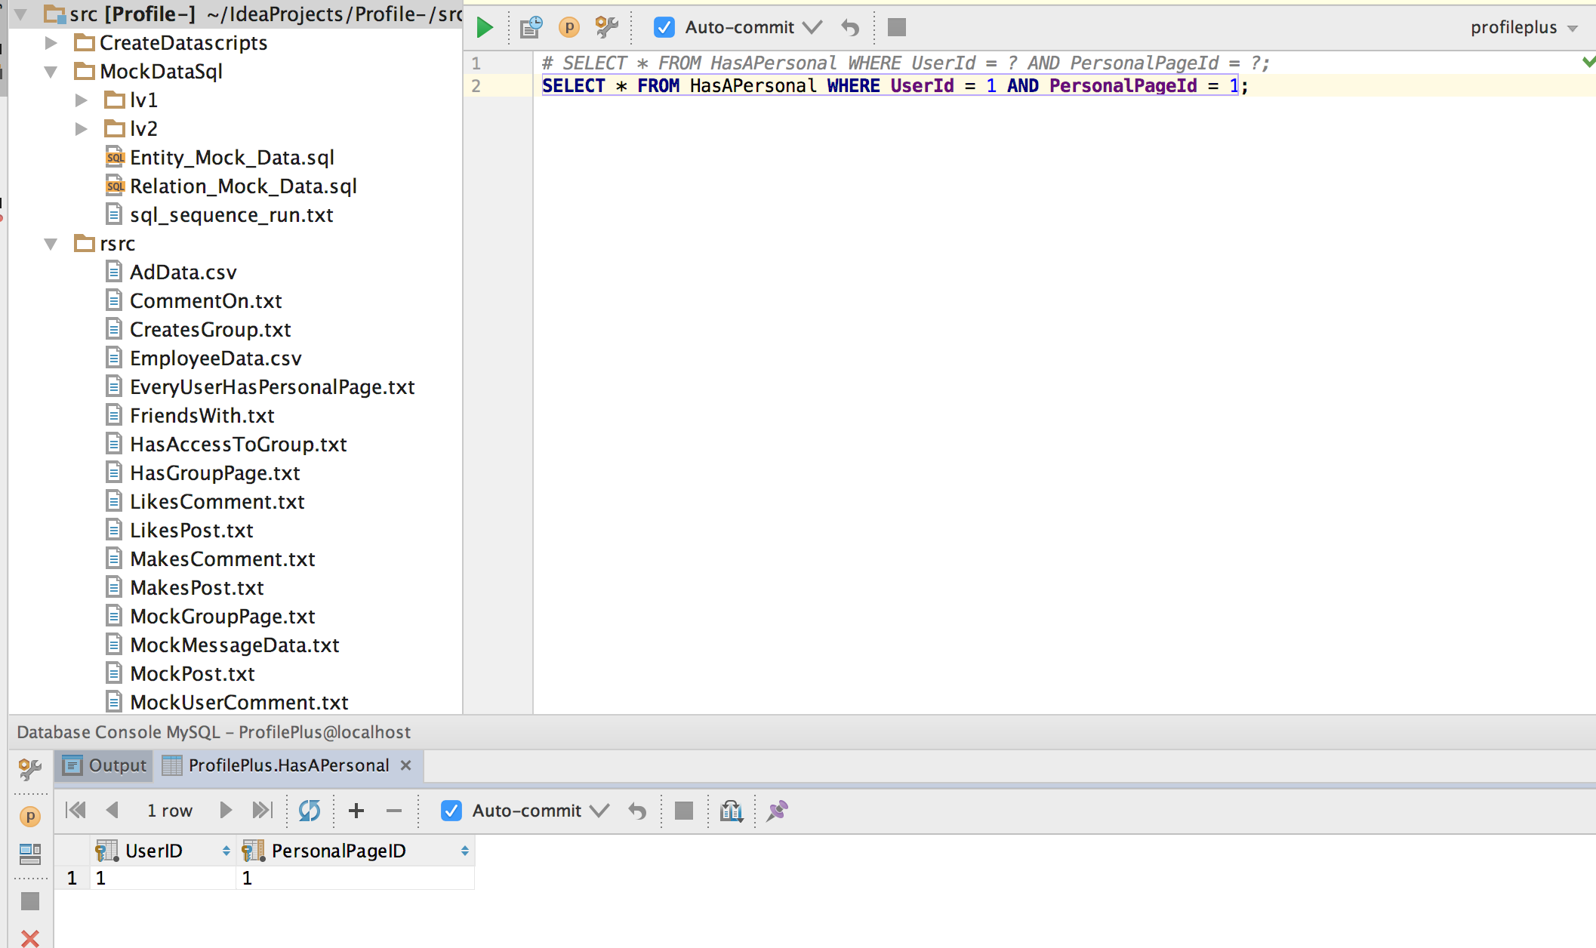

UnJoinGroup.png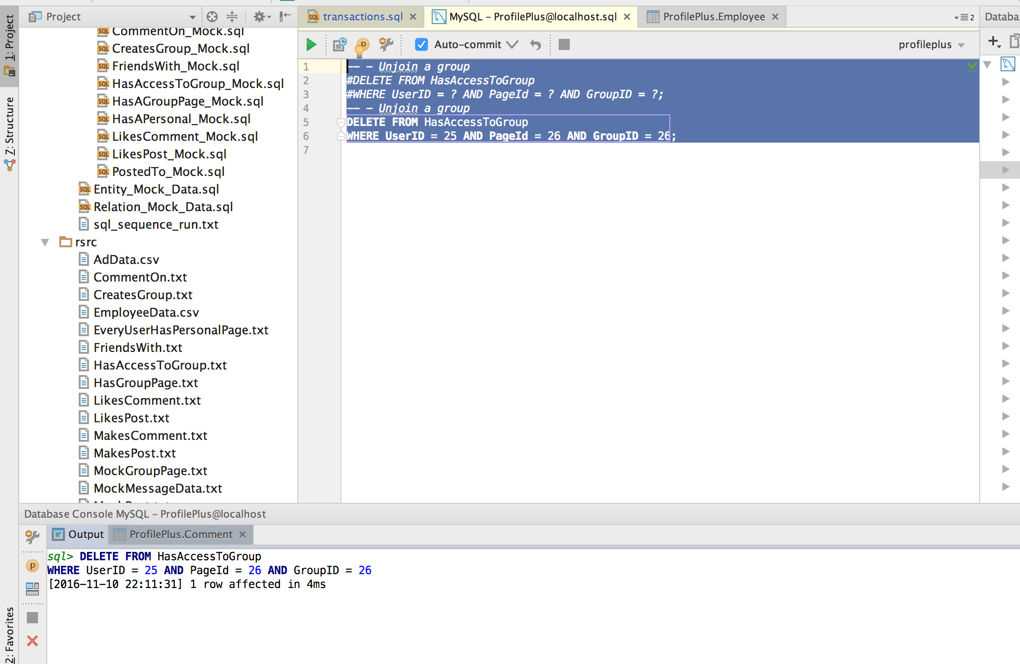

UnLikeCommentInGroup.png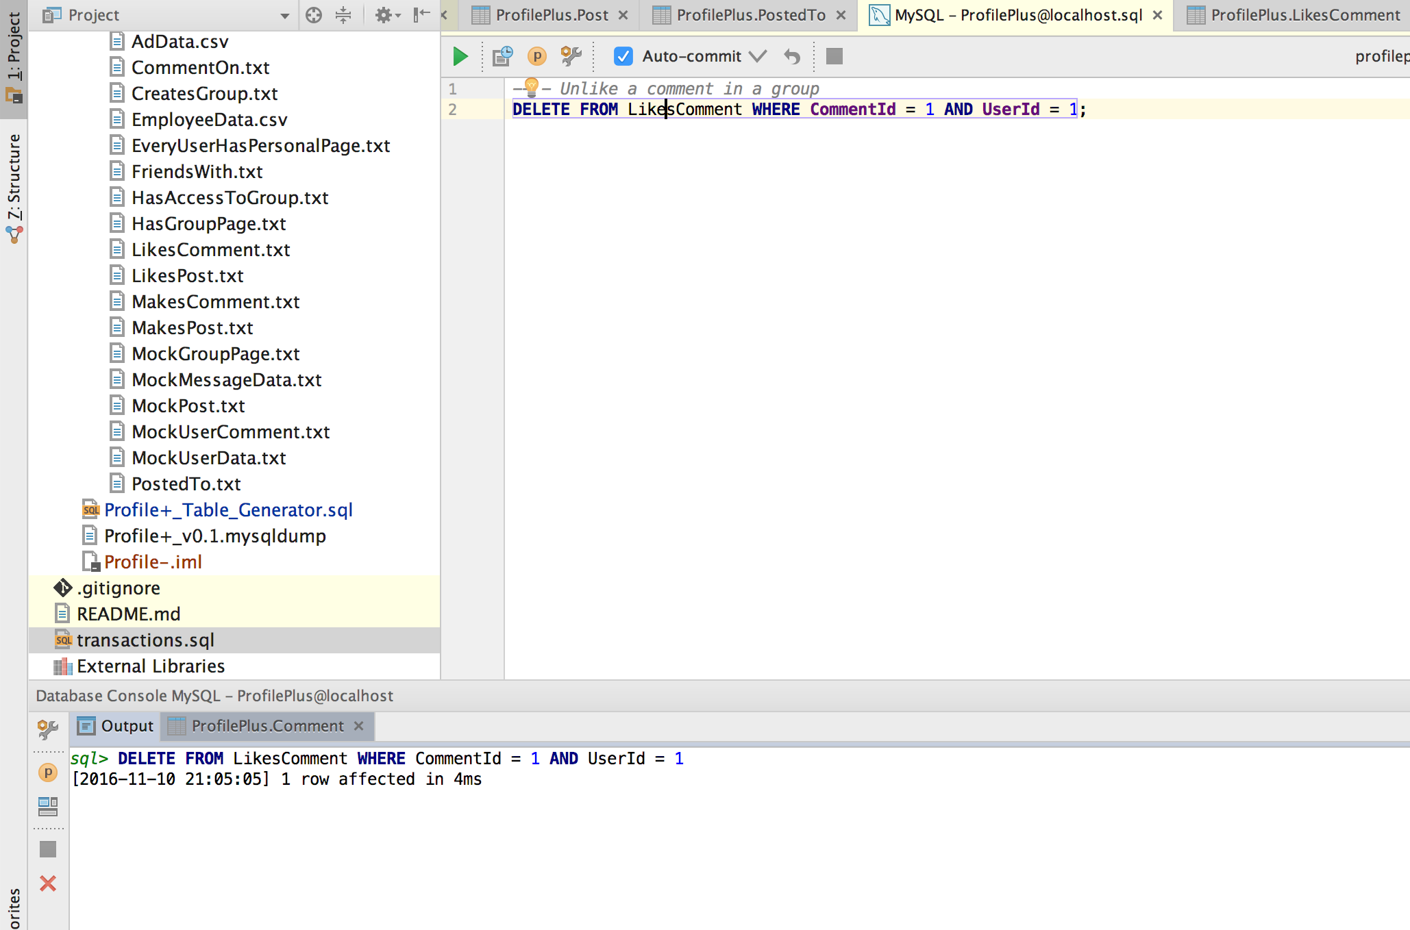

UnlikePostFromGroup.png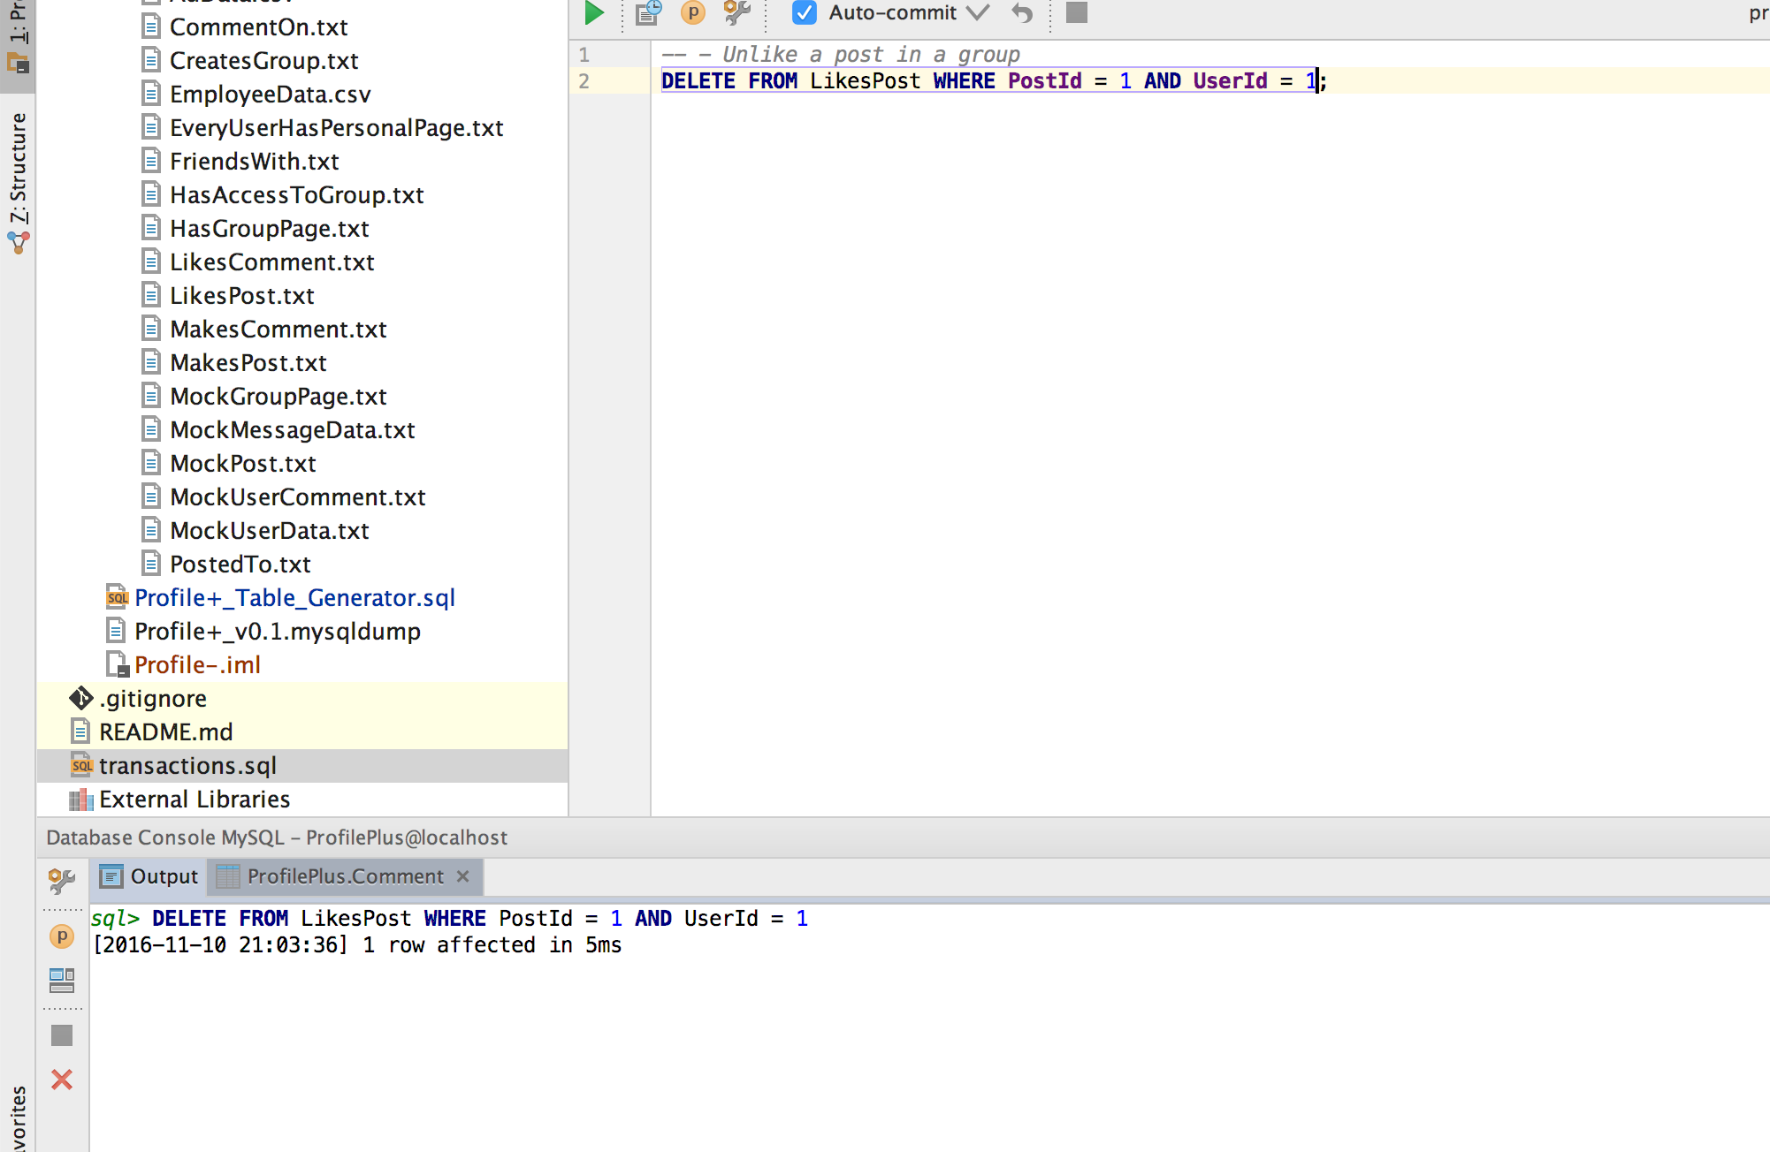

UpdateComment.png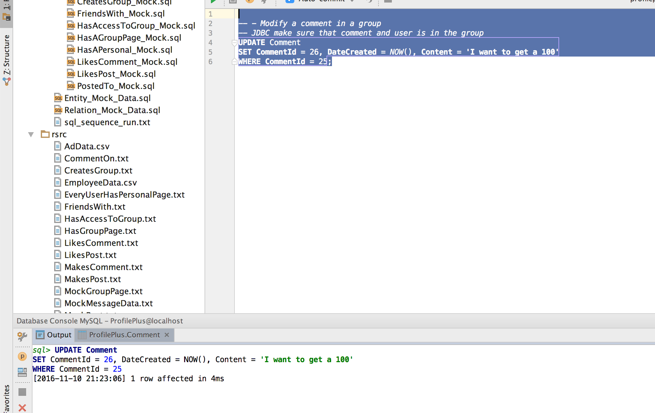

UpdateEmployee.png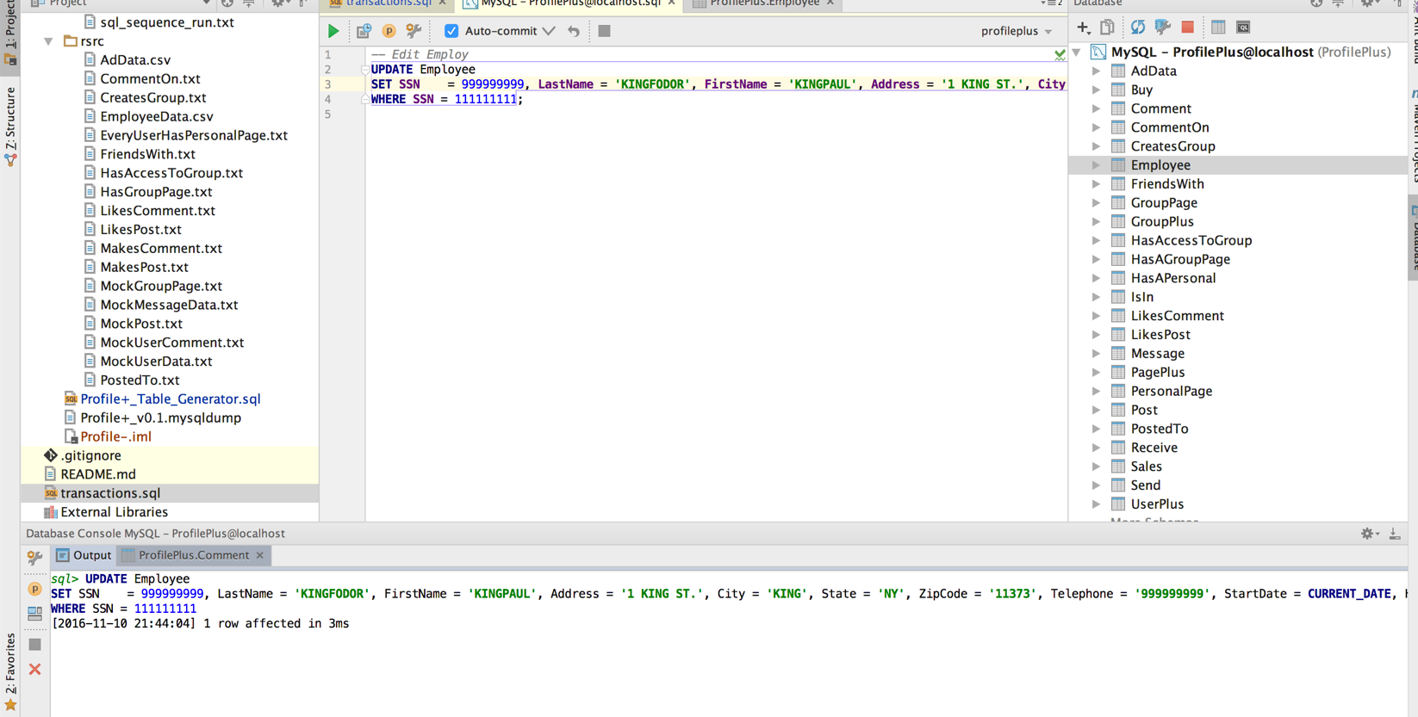

UpdatePost.png